Robotics

**Unit 6 User’s Guide**

Integrating Sensors

horizontal line

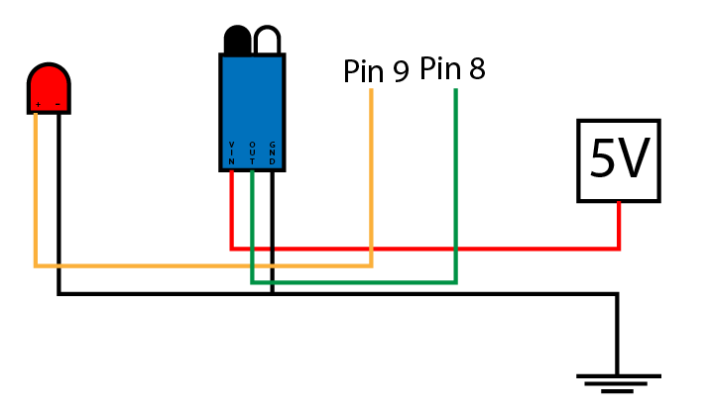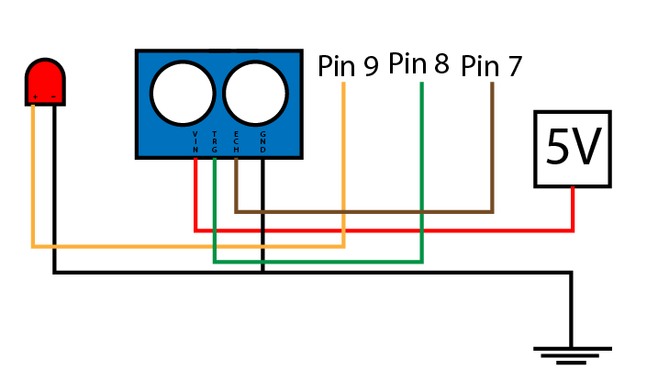

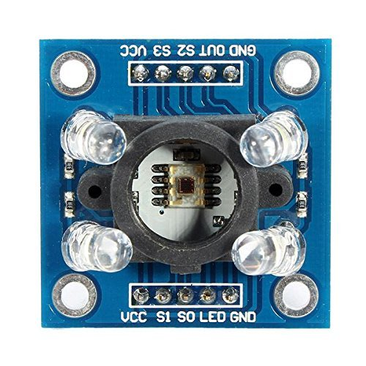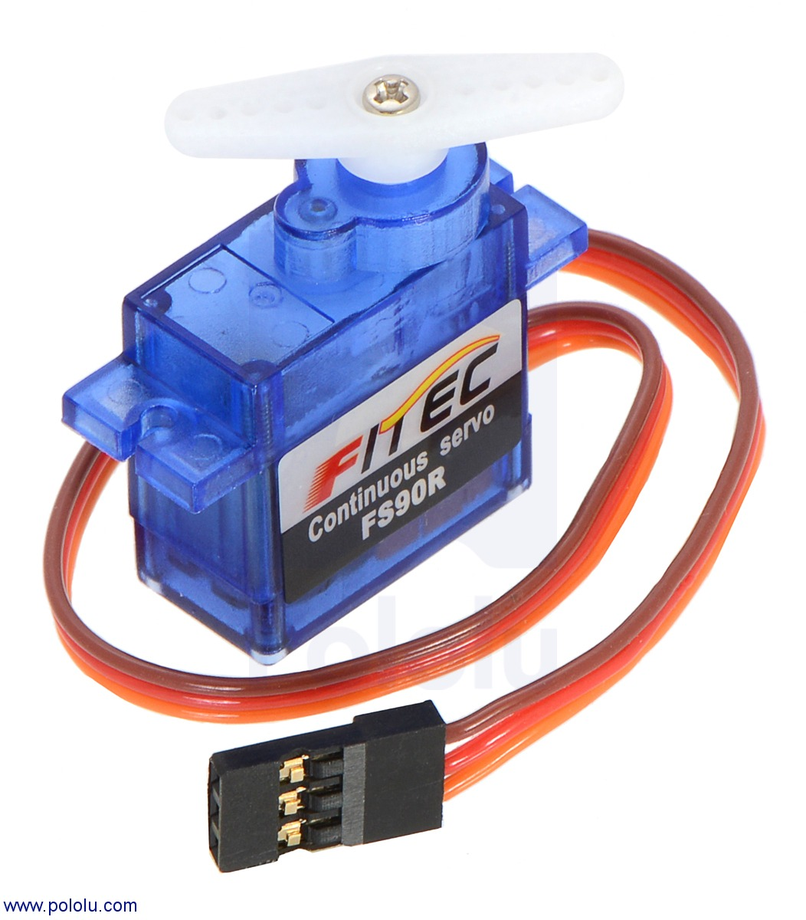

**Ctrl+Alt+Elite**

**CONTENT OF UNIT 6 SLIDES**

**Unit 6 : Integrating Sensors**

**Section 1: InfraRed Sensor**

* What are IR sensor
* Why are they used
* Activity #1
  + Build a circuit using an IR sensor, an LED, resistor and an Arduino board

**Section 2: Ultrasonic Sensor**

* What are Ultrasonic sensor
* Why are they used and what are they for.
* Activity #2
  + Build a circuit using an Ultrasonic sensor and an Arduino board

**Section 3: Color Sensor**

* What are Color sensor
* Why are they used and what are they for.
* Activity #3
  + Build a circuit using a color sensor and an Arduino board

**Section 4: Servos**

* What are servos
* Why are they used and what are they for.
* Activity #4
  + Build a circuit using a servo and an Arduino board
* Activity #5
  + Build a circuit with an Ultrasonic sensor and an IR sensor on an Arduino board

# OVERVIEW

# Students will explore integrated sensors through different means. This unit is an advanced part of circuit. Students should how to build a circuit using an IR sensor and an Arduino board. Likewise they should also be able to build circuit using a Ultrasonic sensor and an Arduino board. Students should be able to differentiate between the sensors used in this unit. Students should know how each work work and why they are used.

# FOCUS STANDARDS

# From our experience implementing this unit, we have selected these focus standards.

# Describe what an InfraRed sensor is.

# Describe what an Ultrasonic is.

# Describe what a color Sensor is.

# Engage effectively with the student to ensure they understand what sensors are and why we use them and how it relates to their project.

# Go over the observations made during the making of the activities in this unit.

# Explain why Sensors are needed for the project and why sensors are needed in general.

# Describe how sensors work.

# OBJECTIVES

These set objectives are to be checked at the end of this unit. Students should know the minimum of the following objectives to move forward.

Student should know Infrared Sensors. What they are and Why they are used.

Students will learn about Ultrasonic Sensors

Students will learn about Color Sensors

Students will learn about Motors

Students should know about Servos.

Students will learn about MOSFETs.

# SAMPLE ACTIVITIES

The activities listed below are to completely by the end of this unit. All of them are build using materials leaned in this unit.

* Build a circuit using an IR sensor, an LED and Arduino.
  + Write a code that can can be used to program the Arduino.
* Build a circuit using an Ultrasonic Sensor.
  + Write a code that can can be used to program the Arduino.
* Build a circuit using an Color sensor, an RGB and Arduino.
  + Write a code that can read the colors from the color sensor.
    - Use the serial monitor window to read the OUTPUT generated.
* Build a circuit using a Servo and an Arduino Uno board
  + Write a code that can make the servo turm.
* Build a circuit using a Arduino, resistor, an LED and a MOSFET.
* Build a circuit using an IR sensor and an Ultrasonic sensor.

# BILL OF MATERIALS

* **List of Materials needed for this unit (per student)**
  + InfraRed Sensor
  + UltraSonic Sensor
  + A motor
  + Servos
  + Arduino
  + Laptop
  + Color Sensor
  + Arduino IDE
  + RGB LED
  + MOSFETs
  + Wires
  + Resistors
  + Regular LEDs
  + RGB LEDs
  + Arduino Cable

# 